Assignment-24.3:

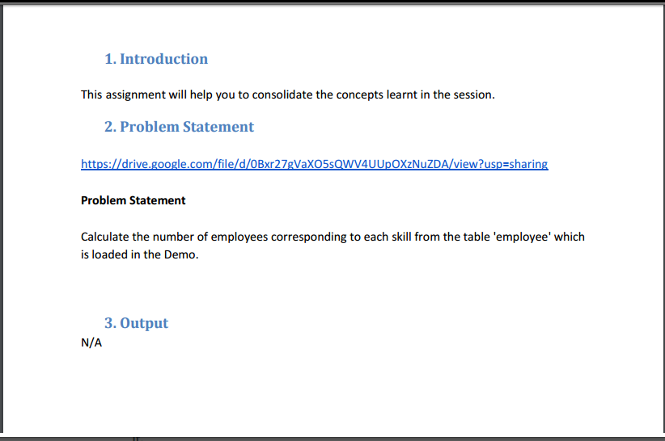

A table named employee is created and the data is loaded from the local filesystem. The Contents of the table is displayed.

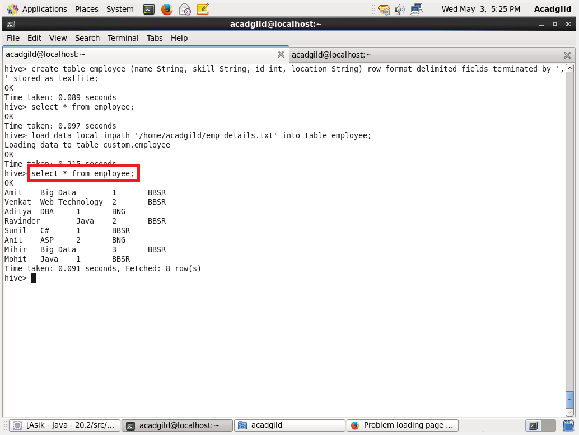

The number of employees corresponding to each skill is displayed below.

